**Name: LIBIYA JOSE**

**Roll No: 14**

**Batch: RMCA B**

**Date:08/03/2022**

**ADVANCED DATABASE MANAGEMENT SYSTEM LAB**

**Experiment No.: 3**

**Aim**

To familiarize DDL Commands- ALTER,DROP,TRUNCATE,RENAME

**Question**

1.Create a table emp with attributes empno number(4)as primary key, ename char(10),hiredate,  salary, commission.

insert 5 rows of data

|  |  |  |  |  |
| --- | --- | --- | --- | --- |
| 101 | Ramesh | 17-Jan  1980 | 5000 |  |
| 102 | Ajay | 05-Jul  1985 | 5000 | 500 |
| 103 | Ravi | 12-Aug  1981 | 1500 |  |
| 104 | Nikesh | 03-Mar  1983 | 3000 | 700 |
| 105 | Ravi | 05-jul  1985 | 3000 |  |

2.Modifying the structure of tables

a.Add new columns: sal number(7,2)

b.Dropping a column from a table: sal

c.Modifying existing column :ename varchar2(15)

d.Renaming the tables: emp to emp1

e.truncating the tables:emp1

f.Destroying tables:emp

3.Create a table stud with sname varchar2(20) primary key , rollno number(10) not null,dob  date not null

4.Create a table student as regno number (6), mark number (3) check constraint (mark >=0 and  mark

<=100));

In table student add check constraint(length(regno<=4))

5.Create a table cust with(custid number(6) constraint unique, name char(10) 6. Refer the table “stud” in table “ student”

**Procedure**

**Create table emp:**

CREATE TABLE EMP( EMPNO INT PRIMARY KEY , ENAME CHAR(10),HIREDATE DATE, SALARY INT,COMMISION INT);

INSERT INTO EMP VALUES(101,'RAMESH','1980-01-17',5000,0);

INSERT INTO EMP VALUES(102,'AJAY','1985-07-05',5000,500);

INSERT INTO EMP VALUES(103,'RAVI','1981-08-12',1500,0);

INSERT INTO EMP VALUES(104,'NIKESH','1983-03-03',3000,700);

INSERT INTO EMP VALUES(105,'RAVI','1985-07-05',3000,0);

**OUTPUT SCREENSHOTS**

SELECT * FROM EMP;

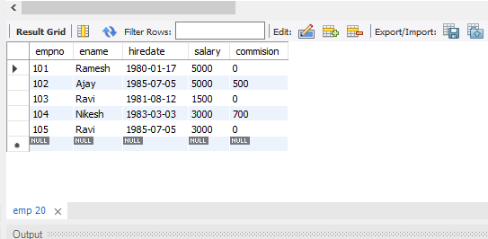

ALTER TABLE EMP ADD SAL INT;

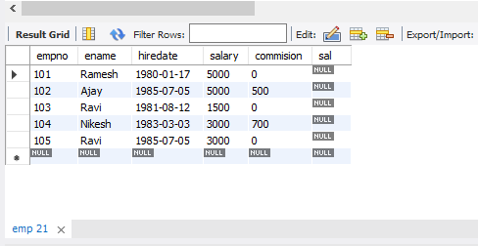

ALTER TABLE EMP DROP COLUMN SAL;

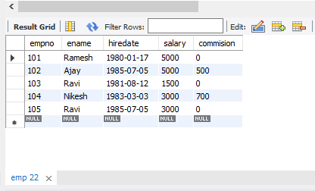

ALTER TABLE EMP MODIFY ENAME VARCHAR(15);

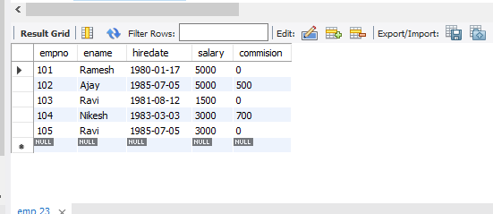

RENAME TABLE EMP TO EMP1;

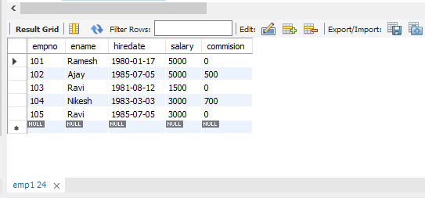

TRUNCATE TABLE EMP1;

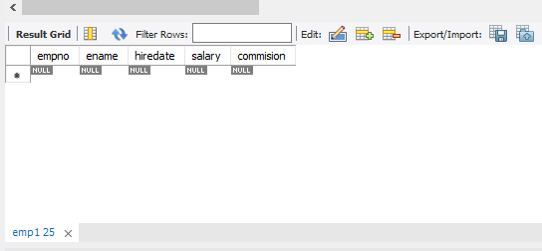

DROP TABLE EMP1;



CREATE TABLE STUD(SNAME VARCHAR(20) PRIMARY KEY, ROLLNO INT NOT NULL, DOB DATE  NOT NULL);

SELECT * FROM STUD;

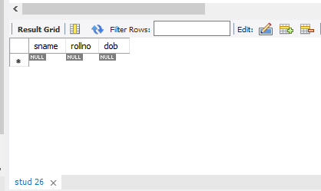

CREATE TABLE STUDENT (REGNO INT, MARK INT(3) CONSTRAINT B CHECK (MARK >=0 AND MARK <=100));

SELECT * FROM STUDENT;

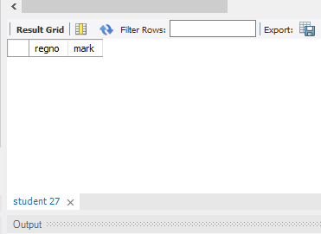

CREATE TABLE CUST(CUSTID NUMBER(6) UNIQUE, NAME CHAR(10));

